# MASTER ANALYSIS PROGRAM

## Purpose and USe

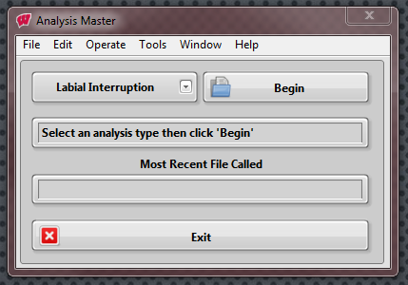The Master Analysis program contains all of the analysis programs for our aerodynamic measurement devices. This can be opened from the Master Aero Program or can be used through the stand-alone Analysis Master.

The main front panel provides the user with an analysis option in a drop-down menu. Once a method is selected, click Begin.

## Block Diagram

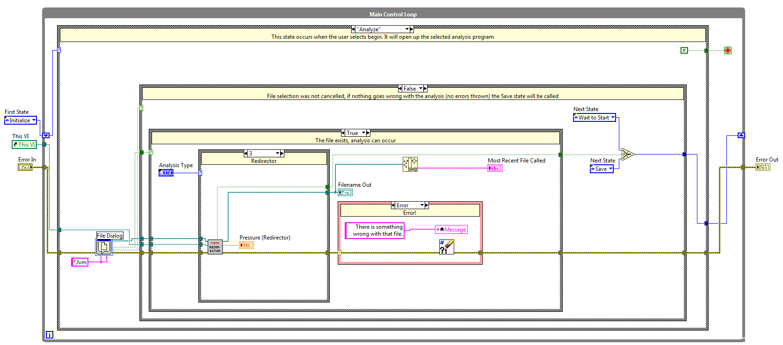This is set up in a state machine format with 5 states. The Analyze and Save cases are more complicated and have multiple nested case structures so I will go into those in more detail later. Right now, here is the basics of each case:

* **Initialize** sends the startup message to the string display on the main front panel
* **Wait to Start** contains an event structure for the Begin and Exit buttons
  + Calls the analysis case is Begin is clicked. The only other option is to exit
* **Analyze** prompts the user to select a file to analyze then, based on the selected method, opens the appropriate analysis SubVI
* **Save** uhh…saves the data from the analysis method into a new or existing text file. The case structure within this state helps create the format of the text file. The Save Data SubVI performs the file saving /creation.
* **Exit** is self-explanatory